**30. Design NFA to accept any number of a’s where input={a,b}.**

**AIM:** To design NFA to accept any number of a’s where input={a,b}.

**TRANSITION DIAGRAM:**

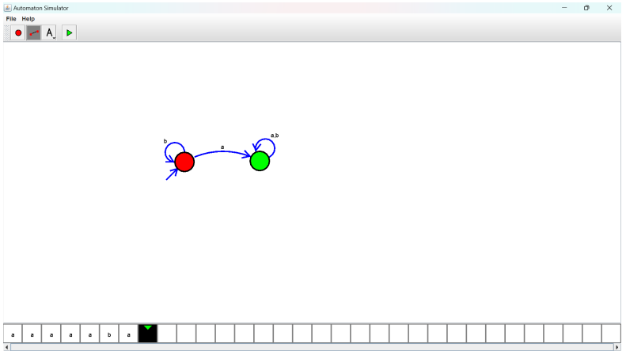

**RESULT**: Hence designing NFA to accept any number of a’s